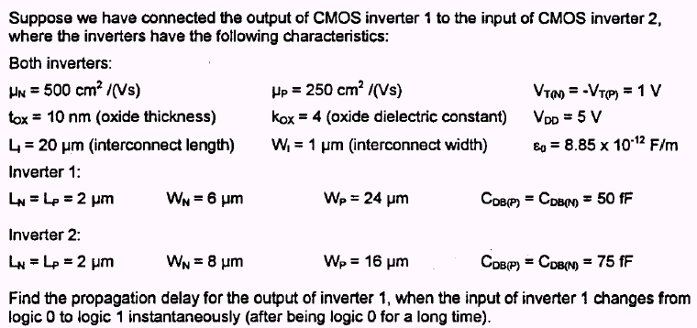

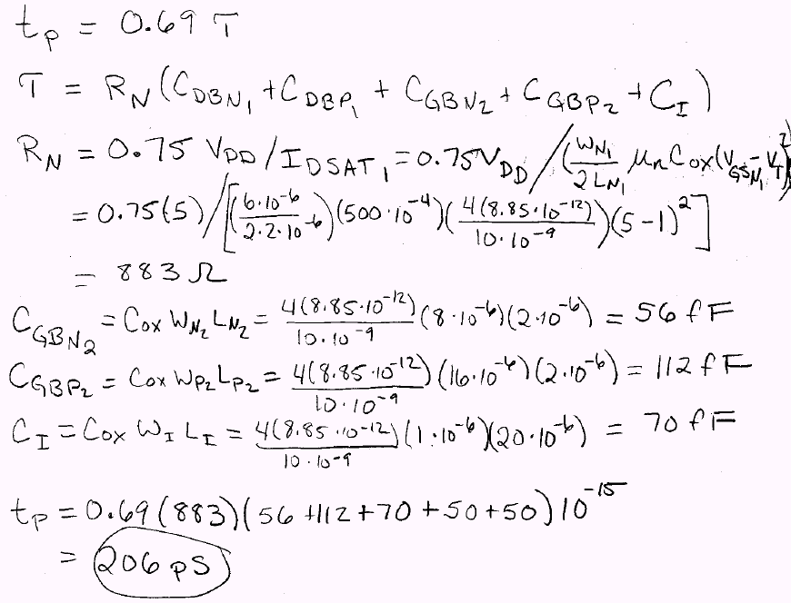

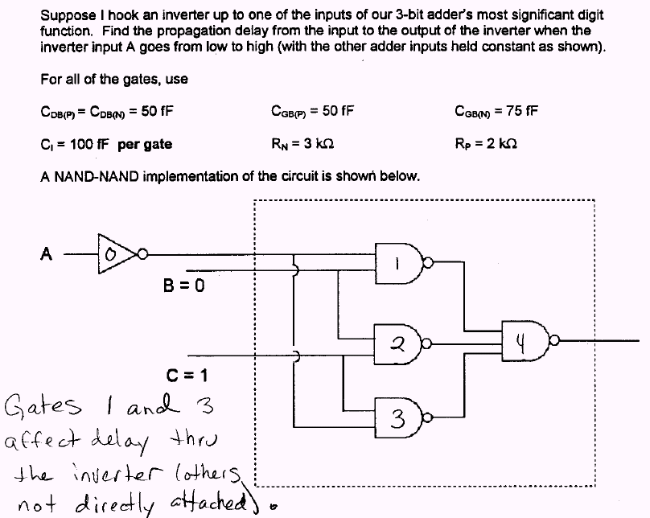

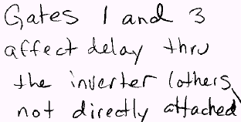
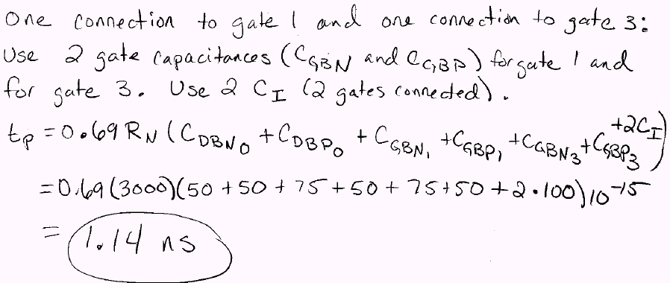

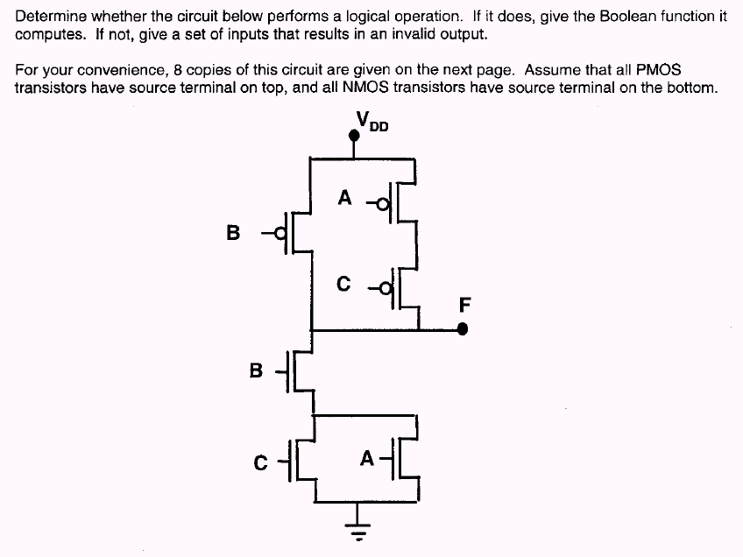

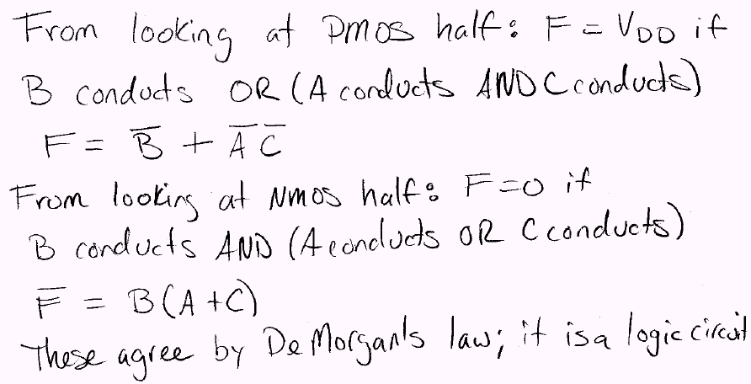

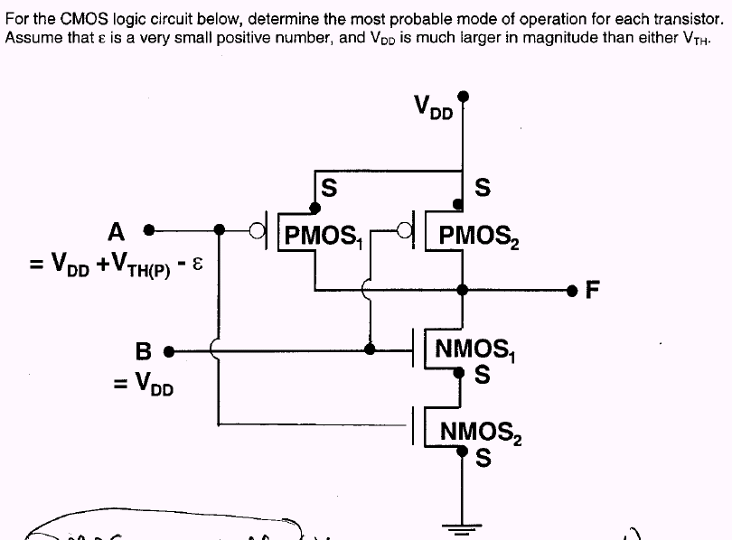

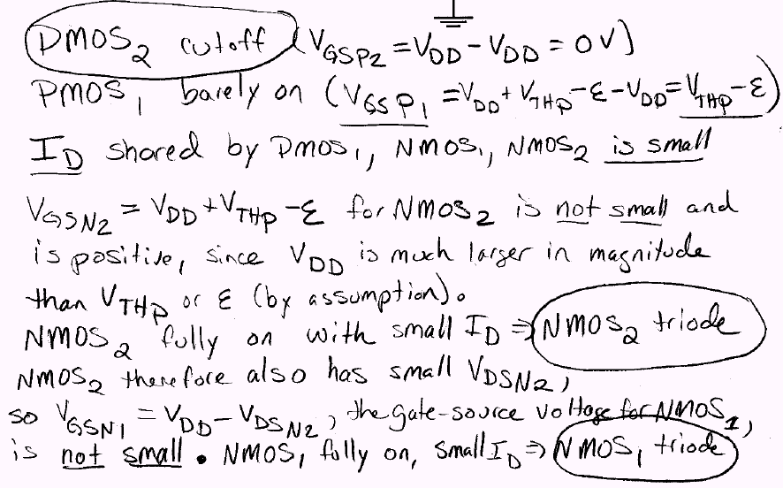
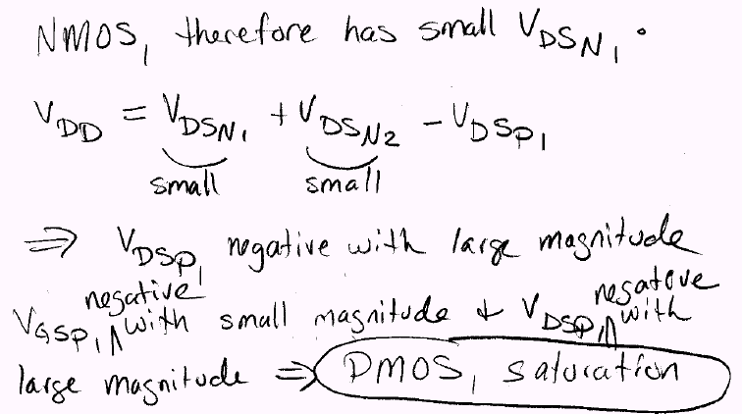

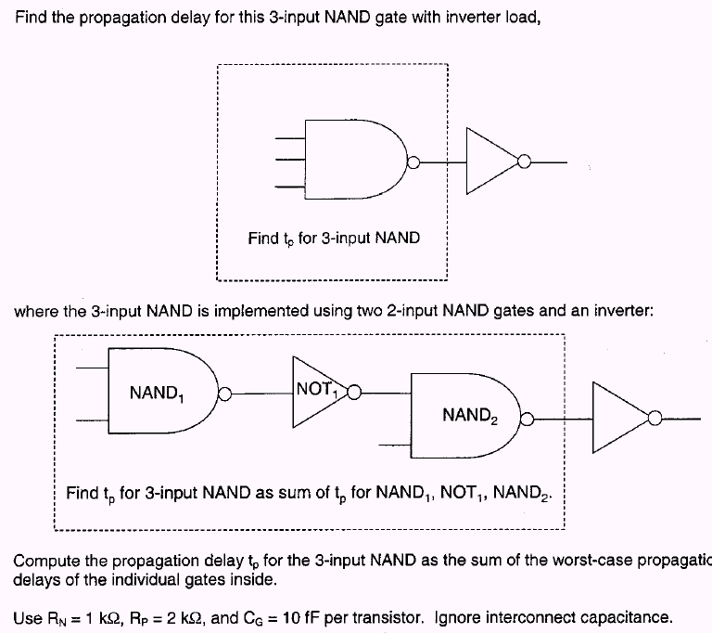

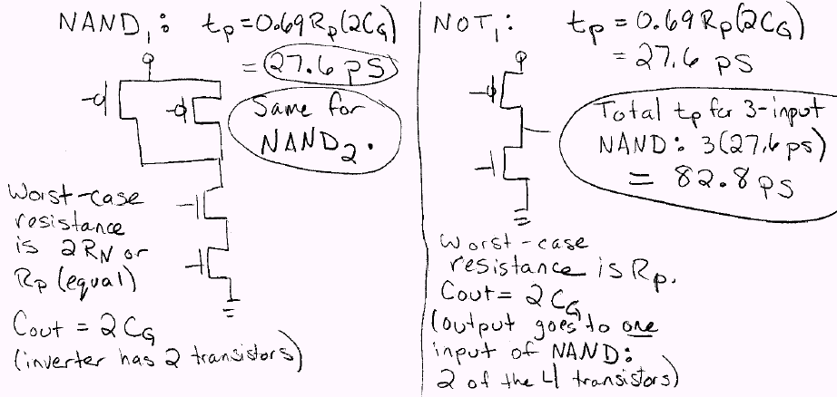

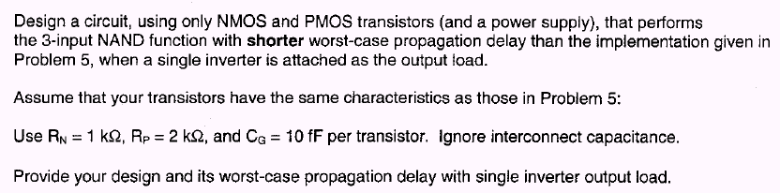

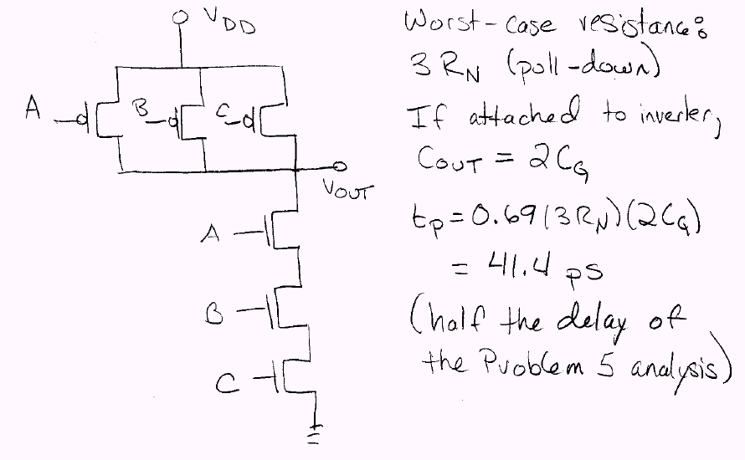

- (4 pts) Find the final value of the voltage V_{o}, as a response to a LH transition at the input as shown in Figures 1.a – 1.d. Assume V_{TN} = |V_{TP}| = 0.5V. Assume that the capacitor is initially discharged, and ignore subthreshold conduction and body effect.
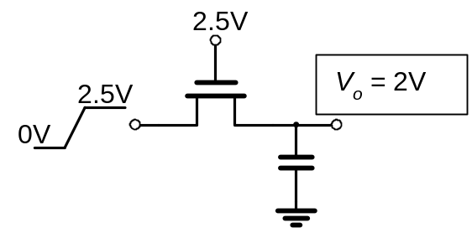 Figure 1.a.
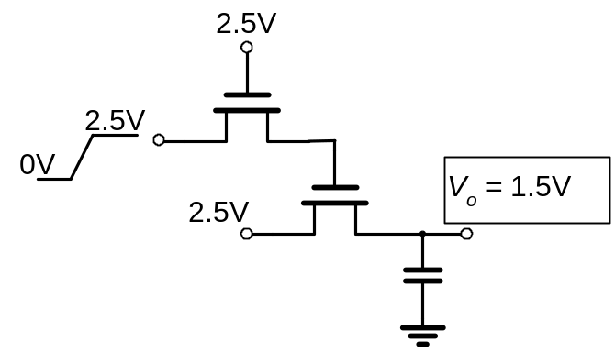Figure 1.b.
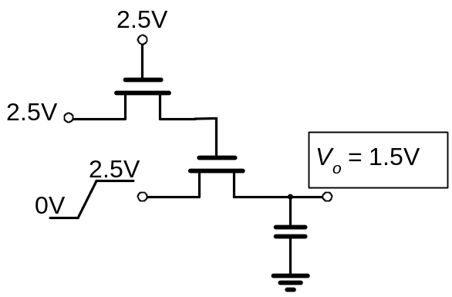Figure 1.c.
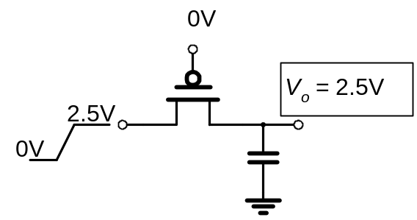Figure 1.d.

b) (2pts) When the output reaches its final value, a 2.5V to 0 step is applied to the input. Determine the energy consumed in the transistors from Figure 1.c. during the transition (in symbolic terms).

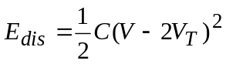
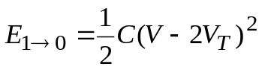

c) (6pts) For Figure 1.d, find the energy dissipated in the transistor during the first 0→ 1 transition. Then, when the output reaches its final value, a 2.5V to 0 step is applied to the input, followed by the second 0 to 2.5V step. Find the energy dissipated in the transistor in the first 1 → 0 transition, and the second 0→ 1 transition (in symbolic terms).

First 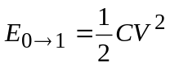

First 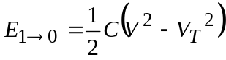

Second 